Counting Affects: Mo(ve)ments of intensity in critical avian education

Abstract

This article seeks to contribute to the idea of ”posthumanist education” by unfolding an educational situation where an assemblage of two humans and 33 former battery hens is gathered to carry out a so-called cognitive bias experiment for two days. A Deleuzian repertoire is set in motion to configure the dynamics of hens intervening in the research schedule and affecting the results in various unexpected ways, as human-avian subjectivities co-emerge in the context of the fieldwork setting. The cognitive bias experiment ends in an ultimate line of flight; an act of animal liberation: The hens are moved from the research facility, where they were scheduled to be euthanized, to a private home in the countryside.

Key words: avian subjectivity; assemblage; affects; intensity; bio-choreography

Critical avian education: Background and take-off

How may formal educational knowledge-practices shift or transform in the physical presence of nonhuman animals? What happens when conventions of science are momentarily swept up by the disparate agendas of a learning constellation composed of a student activist and her experimental subjects – in this case; a number of laying hens? In the following I will unfold a specific learning situation where the actors involved are 33 former battery hens, one student (“Emma”) carrying out an empirical study (a so-called cognitive bias experiment) with these hens as part of her thesis work in ethology at the BSc level, and myself, in my role as “researcher” during intense immersion in a part of Emma’s work with the hens for two full days. My study sets out with a desire to experience how education practice and posthumanist theory may work together in a closely confined spatial and temporal setting. I primarily turn to Deleuze and Guattari (1987) for inspiration to open up a space of thinking about nonhuman animals, education, and posthumanism – a space open to redefinition of the relationship between thought and affect (Morss, 2004), as well as to the transformational forces of cross-species interventions in an essentially unpredictable situation of education and learning.
My reasons for asking a student, who is also an animal rights activist, for access as a participant observer to her empirical studies are twofold. First, to help me evoke a dimension of critical theory in the idea of “posthumanist education” where the nonhuman animals involved are not only given space to emerge as subjects, but where their emergence becomes part of a larger movement (to be perceived here in a social justice as well as in a Deleuzian sense) toward liberation from confinement, control, and, ultimately, slaughter. Second, Emma’s activism poses resistance not only to the physical control and oppression of animal individuals, but at another level, resistance to the didactic control over the trope of “the animal” as well as the humanist schema that organizes education and science and renders both humans and animals subject to presumably controllable processes. Precisely at this juncture between posthumanism and critique lies the embryo of my approach to a critical avian education where the question of who is enabled to contribute to world-forming processes (cf. Author, forthcoming, 2010) is never already settled.

The cognitive bias project

In the same way that we avoided defining a body by its organs and functions, we will avoid defining it by Species or Genus characteristics; instead we will seek to count its affects. This kind of study is called ethology, and this is the sense in which Spinoza wrote a true Ethics. (Deleuze & Guattari, 1987 p. 257, emphasis added.)

Emma’s thesis project is a so-called cognitive bias experiment with the general aim of gaining insight into the private emotional states of animals; states that are not directly measurable in animals or humans. In the cognitive bias experiment, the animals are trained to associate one cue with a treat, and another cue with something less positive (or unpleasant). They are then presented with ambiguous (intermediate) cues. The hypothesis is that animals in a negative affective state will respond to the ambiguous cue as if they predict a negative event, whereas animals in a positive state will respond in an optimistic manner (Mendl et al., 2009).
The particular purpose of Emma’s cognitive bias study of former battery hens is to find out whether the time passed since the hens (bought from a commercial farm) were moved from conventional battery cages to littered, “enriched” pens, will lead to a change in the hens’ judgment of ambiguous cues – that is, if the hens are more inclined to look positively on life after spending a longer time in remarkably improved living conditions. In my interview with Emma prior to her field study, she says that she believes that this time span will affect the hens in an emotionally positive direction. Emma’s hypothesis draws partly on her previous experiences: She has been involved in activist work with laying hens, been living with hens, and has written a report about the ethical problems with commercial egg production. Her cognitive bias thesis project actually springs from her activist work; she needs empirical data to support the idea that battery cages have a detrimental effect not only on the physical, but also on the psychological wellbeing of the hens.
Despite her thesis project being part of a larger activist agenda, Emma expresses ethical concerns about the fact that she is actually carrying out an animal experiment, however non-invasive, and that she uses caged animals for her own purposes. But she has a specific plan for how she wants the experiment to end:

Emma: After [the experiment] I will arrange for taking the hens with me and give them a good life. /…/

Author: How are you gonna do that?

Emma: I asked [my fieldwork co-advisor] if I can take them with me.

Author: You have already asked?

Emma: Yes, and that was all right. And it feels like a precondition, because I can’t just leave them and say, “yes, now I’m finished with you, bye bye,” knowing that they will be decapitated the next day. That would feel completely wrong. So, now it’s more like, from the hens’ perspective it’s better that I am there, that I come into their lives, than if I don’t.

While Emma’s fieldwork co-advisor has approved of the planned hen rescue, her responsible thesis advisor is not informed: It’s not really relevant, Emma says, since this part has nothing to do with science. However, Emma has read a scientific article in ecology research by Elwood and Appel (2009) where the authors mention the origins of the animals and what happened to them after the experiment. This has inspired Emma to consider writing about the rescue part in her thesis.

Bodies in (e)motion: Bio-choreographies of learning

On the first day of my participation in Emma’s fieldwork at the research facility, I enter an assemblage composed of 33 hens, housed in groups of two to five in a total of ten pens, and Emma herself. No teacher or supervisor is present. In the corner of the room there is a semi-circled training and testing arena, equipped with a small “start box” with a manually handled guillotine door. An old-fashioned video equipment is installed adjacent to the arena, making it possible to film and monitor what goes on behind the walls of the enclosed testing space without making ourselves visible to the hen (a potential source of error in the experimental design). In the training session, the hens are taught that a bowl placed in one corner of the arena contains a treat – a few pieces of corn (Emma has purchased ecologically produced corn from a health food shop for this purpose); whereas a bowl in the opposite corner is empty and brings no reward. Of the 33 hens, only 26 actually take part in the test. The other hens did not meet the learning criteria of the cognitive bias task (i.e., learning to discriminate between bowl placements by taking at least five seconds longer to walk across the arena from the start box to reach the empty bowl, as compared to the bowl containing corn, on at least three occasions in a training session), so they are not included in the test. Also, one hen does not like corn, so she is excluded from all elements of Emma’s study. (Emma tells me that normally, hens who are not suitable for the test situation are euthanized, but this particular hen has been spared.) The hens are given individual names after the number of the pens and the colour of the ring around their legs: “Eight Pink” is thus the name of the hen in pen number 8 who wears a pink ring around one of her legs.
In the micro-geography of the room, human and avian spaces are mutually exclusive. There are basically three locations where a hen can be: In her pen, in the start box, or in the enclosure of the testing arena. Emma and I move around in the other spaces of the room; however, Emma momentarily crosses the borders when she picks up a hen and carries her between cage, box, or enclosure, or moves the corn bowl around in the testing arena. These lines of transport contain the brief moments of physical contact taking place between human and hen in the room.
Emma orchestrates the training and testing sessions in a confident and seemingly experienced manner (although she occasionally swears at her mistakes). Clearly, she is used to handling animals. I assist her in any way I can, in training and testing maneuvers as well as in caring for injured hens. (Quite a few of these former battery hens have wounds or featherless parts of their bodies. One of the hens recently died from a ruptured cloac, and Seven Pink has a similar injury. Emma tells me that the hens have been bred to produce bigger eggs than what is normal for them, which can cause their cloac to rupture.) Emma takes notes on occurrences of feather plucking. When discovering a large wound on Seven Orange, Emma takes a brief break from her research work to wash her and apply salve. When resumed, the lengthy training and testing procedures unfold in a meditative, repetitive flow where Emma’s soft, focused body movements coordinates with the hen’s occasional twisting or flapping until she relaxes in Emma’s hands. The session moments merge seamlessly into a smooth sequence which, to me, sometimes appears with no distinct beginning or end. Emma measures the time with a stopwatch and takes notes with concentrated precision. In-between sessions she steps into the testing arena to remove dirt. She works quickly and efficiently, often in silence, but occasionally with a soft comment or question addressed to the hen, or with an explanation directed to me. I enter the fieldwork site as a researcher, but in our assemblage, relations subtly shift as I become an assistant to Emma, a potential source of error in her study, and a “novel object” to the hens.
The test session is longer than the training sessions, with numerous session moments. Pick up the hen from her cage. Carry her to the arena. Place her in the start box. Place bowl in the arena. Open the door to the start box, exactly the same moment as the beep of the stopwatch sounds. Look at the stopwatch. Look at the video screen. The hen takes a first step out of the start box. Wait until the hen has her head over the bowl in the enclosure. Turn off the stopwatch. Note the result. Open the door to the enclosure, step in, carefully bend over the hen to pick her up. Carry her out of the enclosure and put her back in the start box. Close the lid. Shift bowls, open the door to the start box, and the procedure is repeated. Together, Emma and hens compose a ritualized, micro-physical bio-choreography where their flow of movements unfolds in a pre-defined, but not fully predictable, pattern of detailed design. In the choreography, their bodies come together and part in different frequencies essential to the composition of desirable data. These physical encounters take place in the beginning and end of the training and testing moments, so that the temporary physical contact becomes a marker of the transition between moments. When the hen is exchanged for another, a new sequence or session begins. Now and then, Emma speaks (or cackles) softly to the hen, fondles her, mirrors her facial expression or head movements. After a number of repetitive moments, Emma and hen work in synch as one body, or, rather, as different parts of one body that are physically distinct but still closely attached. The hens’ reward consists not only of corn but of subsequent liberation from the cages and re-homing after the test period is over, as well as “data” that, ultimately, may lead to the liberation of other battery hens; those captivated in a system of agricultural rather than scientific production. Eight Pink, Five Brown and the others cannot choose to opt out from the test situation, no more than they could “opt out” from their forced labour in the factory farm from which they come, but they can complicate, disturb, delay, or change the order of the working scheme. And, as we will see, they frequently do.

The contingency of subjectivity

Not all hens behave as exemplary test subjects. Some might fail the training sessions and disqualify for participation in the test. Some might be reluctant to being picked up. Some might hesitate to exit the start box and enter the testing arena. One hen declines the corn offer. Some escape their pens and flee out in the passage between the pen rows, so that Emma and I have to chase them. Some are “busy” when it is their turn to be tested – Emma explains to me that almost all hens lay eggs in the morning, and then when you decide in the afternoon to finally take them to the test, they are dustbathing! This kind of thing happens frequently. Then you have to wait for half an hour. Emma remarks that the research plan really should be adjusted to the hens’ daily rythms, and they should be tested in the afternoon or evening when most hens are finished with their dustbathing procedure. She has learnt their individual routines.
Precisely this disturbance of the research schedule occurs during one of the training sessions, outlined in my fieldnote excerpt below. While the hen brings forth a temporary activity decrease in the research situation, she paradoxically also fuels a heightened intensity level in the atmosphere of the room:

A loud sound is heard from one of the pens. Emma says that this is the way they sound
when they have laid eggs. Researchers disagree about the reasons. “It’s so cute,” says Emma, “it’s as if they communicate, ‘I have laid an EGG, I have laid an EGG’ (suddenly, Emma loudly performs a perfect imitation of the rising, high-pitched intonation in a hen’s voice, her straightened body posture, blank face and staring gaze), and the rooster responds, ‘Have you laid an EGG, have you laid an EGG’.” Emma says that once the hen did not come out of the [start] box as she was laying an egg inside, and the training session had to be discontinued for a few hours.

Despite the strict reliance on controllability as the core component of the experiment set-up, Emma recognizes, indeed, plays around with, the inherent contradiction of subjecting unruly birds to a research situation whose scientific reliability is predicated on unattainable control:

Now Emma will test Seven Green. “One last time [of testing].” Emma holds a piece of paper in front of the video camera where she has written “TESTING CORN IN THE WRONG PLACE ONE MORE TIME.” Seven Green is in the enclosure. Emma turns to the video screen, observing what is going on in the arena. Seven Green shakes her body. Emma tells me that the hen previously has approached the bowl, but now she doesn’t want to. “I sort of want her to find out herself.” Emma enters the enclosure, picks up Seven Green and places her in front of the bowl. “Watch this,” she tells the hen. Emma squats in front of the video screen again, giggling: “She tried to catch a fly sitting on the lid. It seems difficult to re-learn once you learned something. Strange. A little strange, anyway. Will actually put corn in both [bowls]. Now this will be exciting. I think she will go to the [bowl] she is used to. Yes, I don’t think this gives so much [result], but it’s fun to experiment. This ruins, now I can never test her again, she is entirely messed up.” Emma turns to Seven Green: “What a feast!” (Emma imitates a clucking sound). She picks up the hen, clucks again, tenderly scratching her neck.

Nevertheless, Emma is very concerned about the data her research subjects generate. She verbally instructs or corrects the hens, offers those who “fail” second chances, and gives those who produce a desired result a “star” in her note pad. One of her “exemplary pupils,” Three Pink, expresses a distinct, easily interpretable behaviour in the testing situation. Four Brown, on the other hand, does not get any stars in Emma’s notes:

Now it’s time for Four Brown. She moves immediately across the arena to the bowl. “Now she ran as quickly to the wrong [bowl] [as to the right one]. That was stupid, but optimistic. She runs with the same speed to all [bowls].” Emma turns to the hen: “But it was empty, right? Mm. Too bad. Are you finished?” Emma ponders whether Four Brown will be taken to the test or not. A borderline case.

If Three Pink is top of the class, and Four Brown barely passes the bottom line of the learning criteria, Ten Brown, despite her beautiful plumage, clearly places herself on the “fail” end of the grade scale:

Emma carries Ten Brown out of her pen, scratches her neck and places her in the start box by the testing arena. She will get “one more chance.” I can hear the sound of the hen’s feet in the box. Emma wipes the bowl clean, puts in some corn, places a lid over half of the bowl and places the bowl in the corner of the arena. Emma lets the hen out of the box and turns on her stopwatch. “Well, she’s really absent-minded this hen. I can tell by the way she looks. (Emma imitating the hen) ‘Yes, right, these bowls, yes.’ Hello, now, what about the bowls? One side good, other bad. It’s not so easy for a little hen. She goes, ‘I’m handsome, that’s enough!’ Wow, I don’t know what to say! Jesus, she’s really handsome, not so smart.” Emma turns to the hen: “You get one more chance. Then I don’t know what to do. Sweetheart, this is the last chance.” Ten Brown lets out a cackle in Emma’s arms; Emma cackles back. While still holding the hen in her arms, she scrutinizes her notes on the table and tells me in detail about Ten Brown’s previous test results. Then she suddenly stretches out her arms and holds Ten Brown in front of me, saying that she is extraordinarily beautiful, because she is so soft to the touch, has softer feathers than other hens. “Feel it!,” she says to me. I gently stroke the hen’s back. When Emma carries her to the box, she buries her face in the hen’s plumage.

Counting affects: The porosity of data

The hens in Emma’s study are carriers of important data, whose purpose is twofold: They constitute the necessary empirical material to the thesis work Emma needs to complete in order to get her BSc degree, but equally importantly, they will be the evidence, the scientifically validated authoritative documentation so invaluable when working to abolish the egg industry. The data is entirely quantitative and measured in seconds; however, during her time with the hens, Emma has noticed more subtle messages in her research subjects, such as their facial expression, their body posture when they halt in front of the bowl, and so forth. Of course this won’t do as research data, but, as Emma says, it helps her understand something of what goes on in the hens’ minds. Still, this reveals an ultimate limitation built into the conventions of quantitative data: The hesitation of the hens, their fear, their willingness or unwillingness to let themselves being picked up or to exit the start box, all expressed in the subtle signs of their bodily movements, expressions, postures, is information that Emma would like to add, that is not visible in the data and not counted as part of what is called “data.” Thus, the hens expose – and perform – a data leakage: Their subjectivity and affect (the latter, ironically, what is intended to be measured by the cognitive bias test) permeates the porous contours, the delicate shell around the data, pecking it from within, causing it fine cracks, always already bringing it closer to hatch. The hens thus destabilize the boundary between quantitative and qualitative spheres by imbuing presumably “objective,” quantifiable units with subjective meaning. Emma recognizes that this cannot be captured by the figures measured by her stopwatch, but says that she nevertheless can see it in her figures – the subjective dimensions shine through numerical data, eclipsing them, giving them life and meaning. Data becomes personally coded, but also more than that: Emma thinks that the qualitative information she receives from the hens says much more, and is more reliable, than the static, one-dimensional, quantitative figures. To flesh out these dormant complexities of quantitative data, and figure out how to deal with them as “good” or “bad” data in her scientific work, is part of Emma’s learning process. She has developed her own specific way of handling this by employing parallel systems of documenting results. As a complement to her hand-written tables in which she records test scores (in seconds), she has invented a symbol-based system as follows:

For training:

X = the hen has been trained

= good training result

= even better training result

= distinct, easily interpretable results

For testing:

= the hen has not been tested

T = the hen has been tested
T
= good test result

In addition, Emma gives the hens “pick-up scores,” and notes their willingness (or unwillingness) to exit the start box. She is, however, aware that her symbols will hardly pass a scientific review. Likewise, her dialogue with the hens (as exemplified in the fieldnote excerpts in the previous section) is relation-forming, relation-affirming, and distinctly separate from her scientific repertoire. In her final BSc thesis there is, of course, only room for the latter.

Pecking away at the scientific-educational apparatus

When asking Emma what she feels she has learnt from her empirical study, she replies ”personality.” She has always found personality and individual differences more significant than species affiliation. As an example, she mentions that there are, for instance, cats that are less typical cats and perhaps more parrot-like. Personality, says Emma, is clearly visible also in these hens. Some are more fearless than others when approaching novel objects. One hen dislikes corn and is excluded from the test. Personality is not easily sorted into predefined categories, nor is it easily captured by quantitative data.
Although Emma confirms that she has learnt more from her interaction with the hens than from the experimental data, she also remarks that this learning would not have occurred without the experiment, which allowed her to get “under the skin” of the hens in a way that rarely happens in daily cohabiting with animals.
Formally, the results of Emma’s cognitive bias experiment are more or less the opposite of her initial hypothesis. In her written report, she concludes that the hens were more, not less, negatively biased after a longer stay in the enriched pens, and interprets this as a leveling out of the positive effect of the environmental improvements over time.
Previous critical studies on domestic animals in the intersection of agriculture and scientific knowledge-practices show how animals are produced, enhanced, controlled, and incorporated by various “technologies of intensification” (Boyd, 2001 p. 662) into genetic indexes, productivity statistics, performance records, and standardized quality criteria (Boyd, 2001; Grasseni, 2005; Holloway, 2005; Holloway et al., 2009; Ufkes, 1998). My study suggests a different, more Deleuzian-oriented notion of moments and movements of intensity when avian subjectivity “pecks through,” rather than is appropriated by, the scientific-educational apparatus. These “mo(ve)ments,” and their effects, can roughly be condensed as follows;

Unpredictability of avian activity: Hens intervene in the order of the testing scheme, disturb, change, and delay it; forcing frequent adjustments to the original time plan. Their daily rhythms interrupt the calculated flow of research sequences when they are busy laying eggs or dustbathing at the time of testing. They refuse to exit the start box, or dislike the corn reward.

Confusion in the quantitative –qualitative distinction: By facial expression, body posture and movements, hens mediate important information that cannot be contained by figures. This information permeates the quantitative data and is processed by Emma as a meaningful, but hidden, dimension of data. “Objective,” quantitative data is thus co-composed by an added layer of subjective meaning, marked by the intersubjective relations of the human-avian assemblage.

Instabilities of scientific conventions: In her notes and comments, Emma shifts between the scientific conventions of ethology, and subjective reflections that emerge from her close interaction with the hens. The “results” that the hens generate take shape in the fold between these two spheres. Results are hardly unambiguous and “clean,” but rather multidimensional, complex, and messy – to the extent that they may not even be immediately useful as scientific evidence in Emma’s activist work.

These “mo(ve)ments of intensity” in the cognitive bias test situation collectively embrace radical epistemological imperfection; a posthumanist understanding of what it means to learn with and from, rather than about, nonhuman animals. What kind of learning experience do they set in motion? “Learning,” in this context, may be perceived as essentially a convergence of energies when human and avian subjectivities co-emerge in the flows and currents of the experimental bio-sphere as it unfolds in the specific spatio-material arrangement of the research setting. In this temporarily composed “heterogeneous biosocial assemblage” (cf. Coppin, 2003; Holloway et al., 2009), our relations and positions are dynamic and dispersed rather than fixed; immersed in processes of change and negotiation in which we perform a specter of activities as researchers, assistants, teachers, animal caretakers, animal rights activists, (former) battery hens, students, test objects, “novel objects,” sources of error, corn-haters, and subjects-of-a-life. ”Since each of us was several, there was already quite a crowd.” (Deleuze & Guattari 1987, p. 3) Also the data of the cognitive bias test is characterized by messy multiplicity, and so is their varieties of measurement: Quantitative and qualitative meaning, numerical and symbol-based systems, seconds, scores, and a swift jerk in a hen’s body. “Counting affects,” as a manner of measuring the fundamentally immeasurable in the cognitive bias test, becomes a space of intensity of human-avian intersubjectivity, of learning, as well as of ethology itself. In the process, as Deleuze and Guattari have suggested, it also becomes an ethics. Because just as the hens’ subjectivity continuously imbues the test situation, so does the vision of their ultimate line of flight: their forthcoming liberation.

Landing: Liberation of the experimental subject

The hens are scheduled by the research facility staff to be euthanized the following week – the staff are going to try a new euthanization method – so Emma has quickly arranged, with the consent of her co-advisor, for the re-homing of the hens in the weekend. A couple of Emma’s friends will bring a car to move them to their new home.
A week later I get an email from Emma, with an attached photo of the hens in their new environment, reporting that the transition has been successful. Although her co-advisor does not consider it appropriate to mention the rescue in the BSc thesis, Emma has included the picture (and an additional one), together with the following text in the “Ethical considerations” section:

/…/ After the study was completed, all 33 hens were rehomed to a private home in the country with outdoor access and rooster company, where they will be able to lead the rest of their lives regardless of their utility for humans (Figure 6-7).

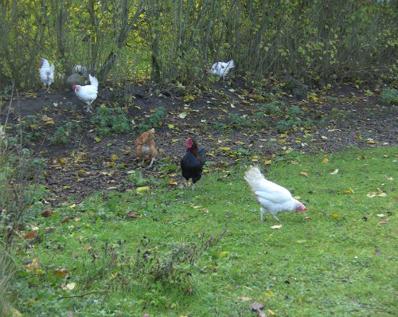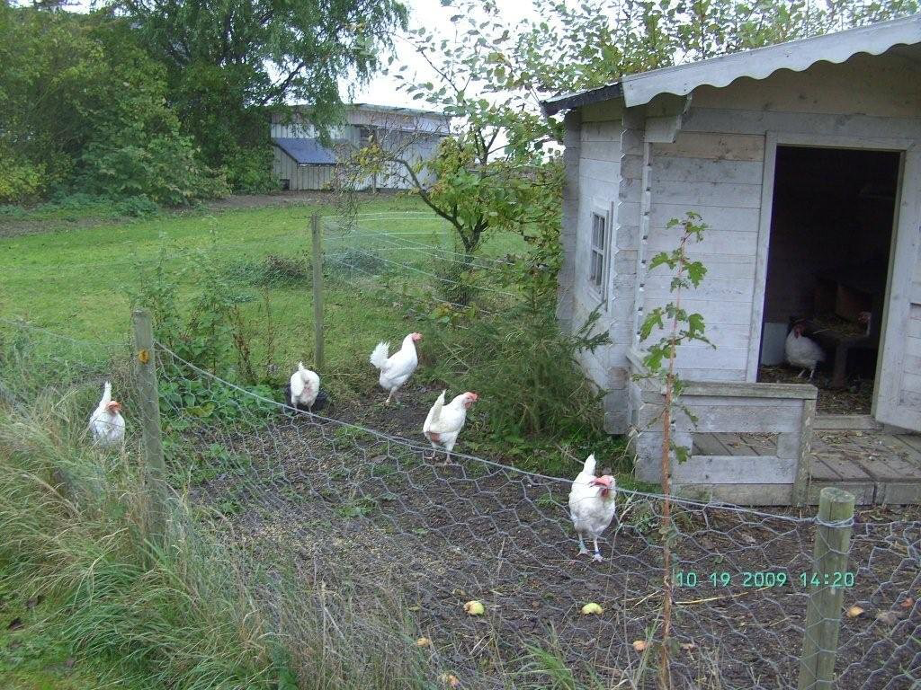
Figure 6-7: The life of the hens after the study.

Under the “Acknowledgements” section in her thesis, Emma thanks the new caretakers:

/…/ Two months after [the hens] arriving there [in their new home], they are reported to all have feather score 0 [no obvious naked parts] and “look like little angels.” /…/

Counting affects. Again.

References

Author (forthcoming in 2010).

Boyd, W. (2001). Making Meat: Science, Technology, and American Poultry Production.
Technology and Culture, 42, 631-664.

Coppin, D. (2003). Foucauldian Hog Futures: The Birth of Mega-Hog Farms. The
Sociological Quarterly , 44(4), 597-616.

Deleuze, G. & Guattari, F. (1987). A Thousand Plateaus: Capitalism and Schizophrenia.
Minneapolis and London: University of Minnesota Press.

Elwood, R.W. & Appel, M. (2009). Pain experience in hermit crabs? Animal Behaviour,
77(5), 1243-1246.

Grasseni, C. (2005). Designer Cows: The Practice of Cattle Breeding Between Skill and
Standardization. Society & Animals, 13(1), 33-49.

Holloway, L. (2005). Aesthetics, genetics, and evaluating animal bodies: Locating and
displacing cattle on show and in figures. Environment and Planning D, 23, 883-902.

Holloway, L., Morris, C., Gilna, B., & Gibbs, D. (2009). Biopower, genetics and livestock
breeding: (re)constituting animal populations and heterogeneous biosocial collectivities.
Trans Inst Br Geogr, 34, 394-407.

Mendl, M., Burman, O.H.P., Parker, R.M.A., & Paul, E.S. (2009). Cognitive bias as an
indicator of animal emotion and welfare: Emerging evidence and underlying
mechanisms. Applied Animal Behaviour Science. 118, 161-181.

Morss, J.R. (2004). Gilles Deleuze and the Space of Education: Poststructuralism, Critical
Psychology, and Schooled Bodies. In J.D. Marshall (Ed.), Poststructuralism,
Philosophy, Pedagogy (pp. 85-97.). Dordrecht: Kluwer Academic Publishers.

Ufkes, F.M. (1998). Building a Better Pig: Fat Profits in Lean Meat. In J. Wolch, & J. Emel
(Eds.), Animal Geographies: Place, Politics, and Identity in the Nature-Culture
Borderlands (pp. 241-255). London and New York: Verso.

